Open Excel –

**Select DATA tab –**

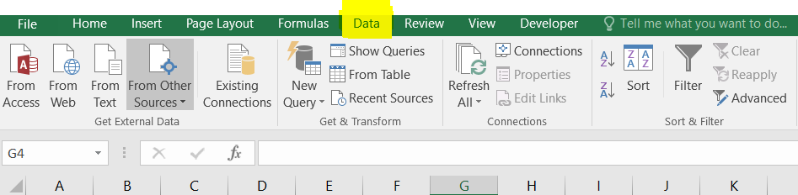

**Select New Query –**

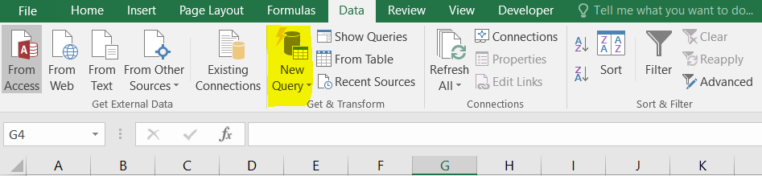

**Keep all the downloaded txt files in one folder.**

**Select the Folder of GCP txt files using “From Folder” –**

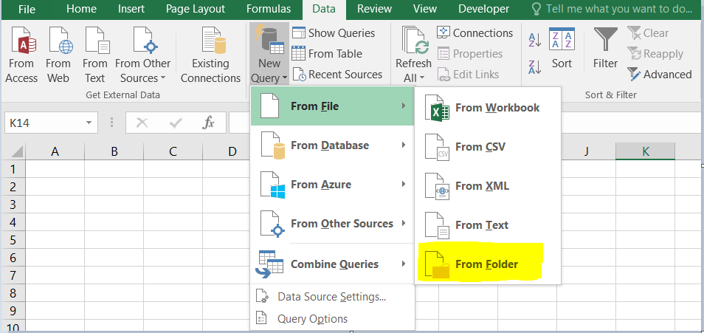

**Click on Edit Button –**

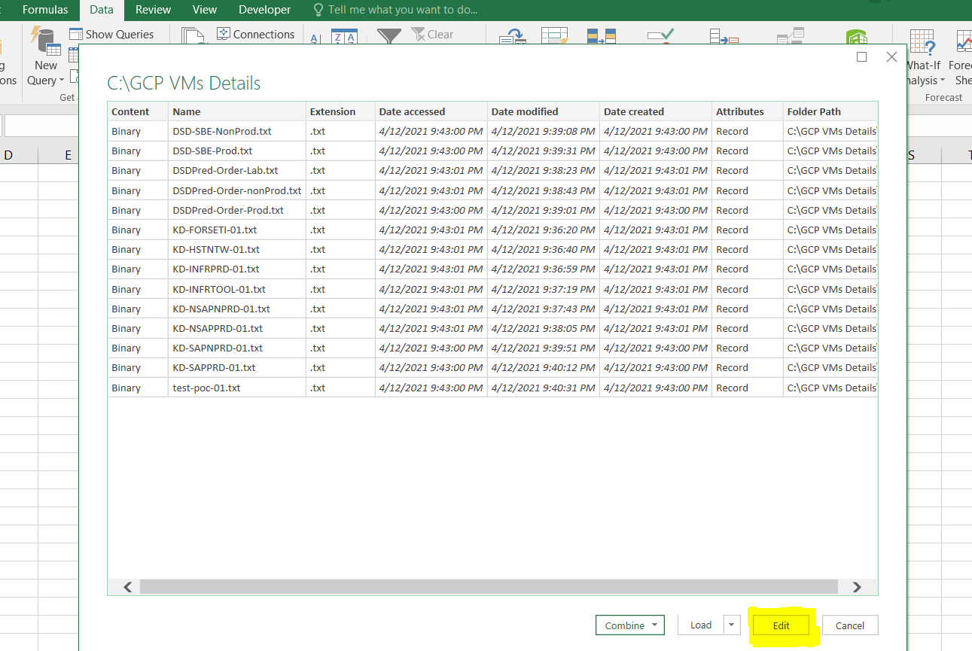

**Click on Content Icon –**

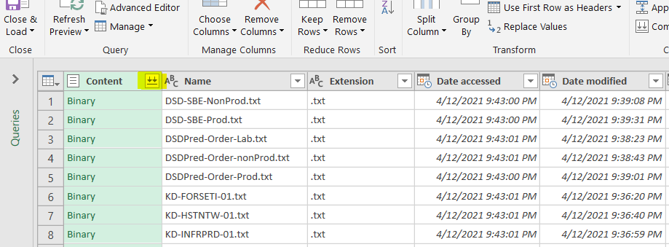

**Click on Load –**

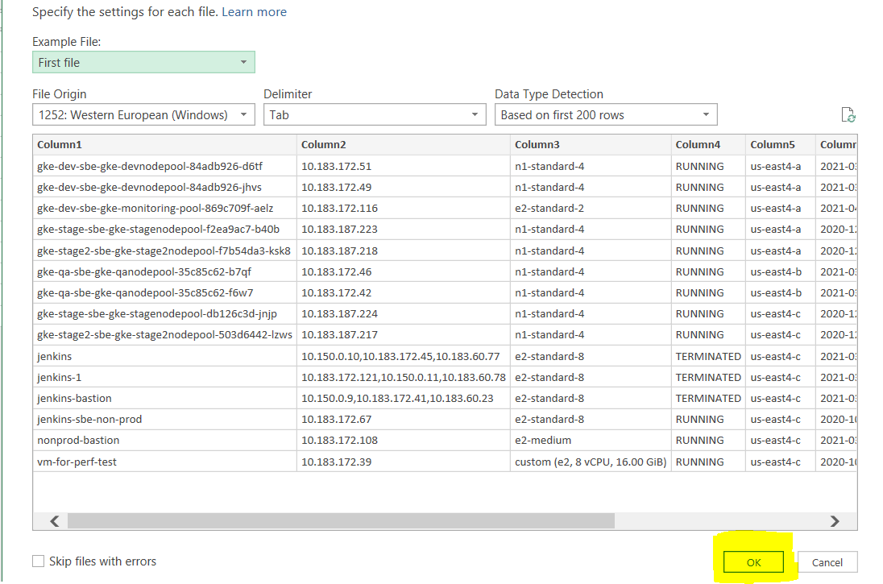

**Close & Load the DATA –**

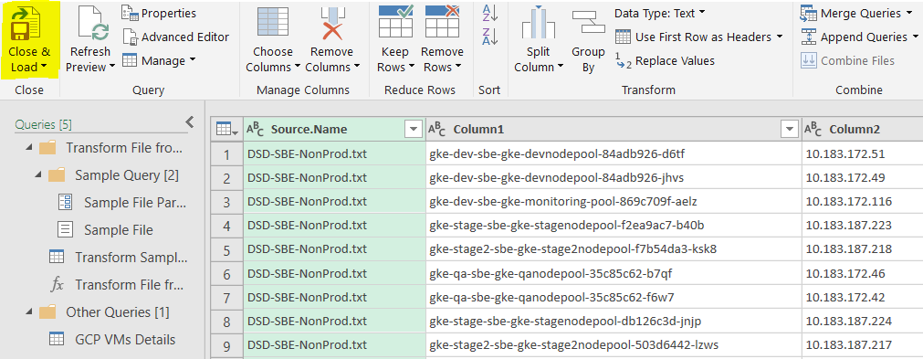

**Now Data will be available on the Excel Sheet**